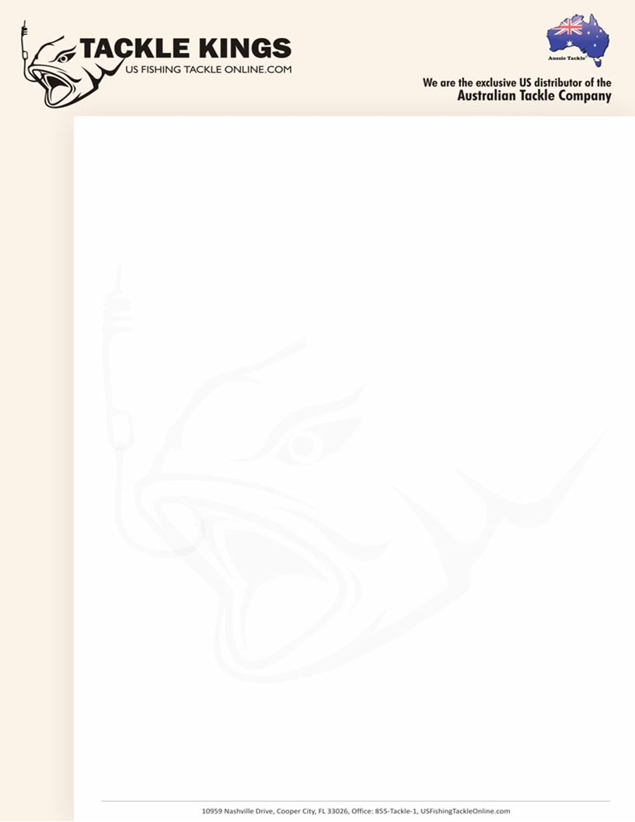 **Steel Tie Press Release**

Tackle Kings LLC is proud to be the exclusive US distributor for the Australian

Company’s Tournament Range of Fishing Tackle. The Australian Tackle

Company’s BRAND NEW Interchangeable Swim Jig in coming in Sept 2011.

The Interchangeable Swim Jig won 1st and 3rd in the first tournament that it

was used it.

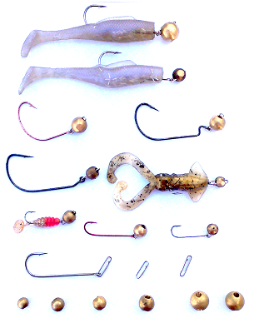

Aussie Tackle’s Interchangeable Swim Jig won 1st & 3rd during it's only ever

entered U.S. Tournament. It lets YOU CHOOSE which "Hook, which Weight &

which Bait” BUT......its ability to catch fish is what will have you screaming out

for more. Coming this September 2011.

Come see this amazing new product at the Tackle Kings booth #2037 at iCast.

Tackle Kings will be offering a ‘show-only’ special for any orders that are written

during the three exhibiting days of iCast. We will also conduct a raffle for an

iPod Touch for any company that places an order during the iCast show.

For more information about this product or any of the other Aussie Tackle ‘Knot

Lock’ products please call our office at Toll-Free 855-TACKLE-1. Ron Lewis

will be extension 1 and Doug Towle will be extension 2. You can also take a

look at our new website at <http://www.usfishingtackleonline.com>.