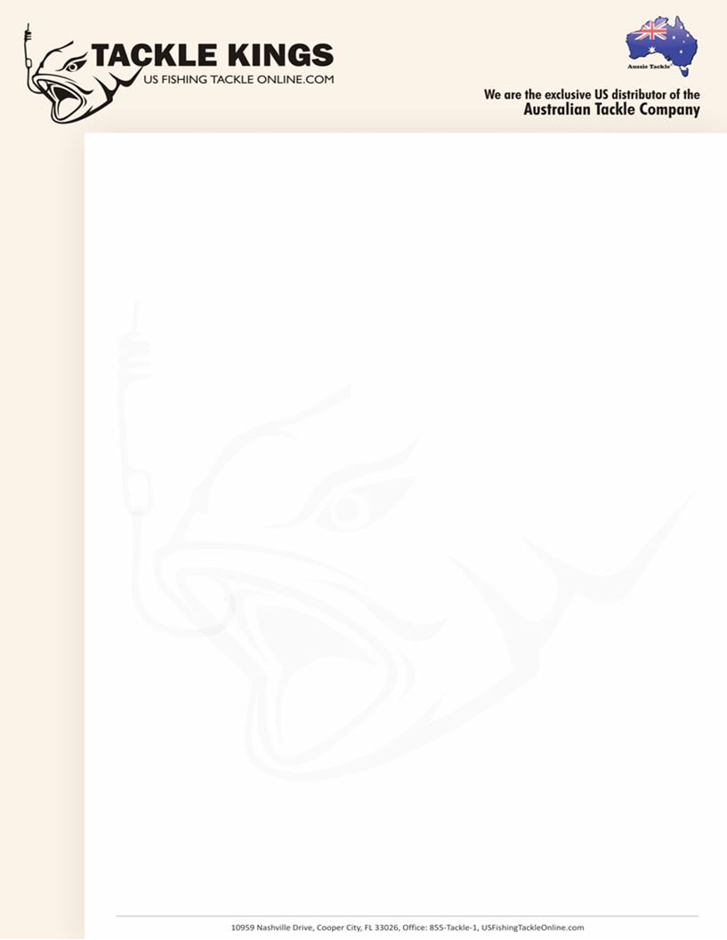 **Braid to Mono Swivel Press Release**

Tackle Kings LLC is proud to be the exclusive US distributor for the Australian

Company’s Tournament Range of Fishing Tackle. The Australian Tackle

Company’s Aussie Tackle ‘Knot Lock’ branded products offer the easiest way

to attach Braided Line, Fluorocarbon or even Steel to a leader, lure or even a

hook.

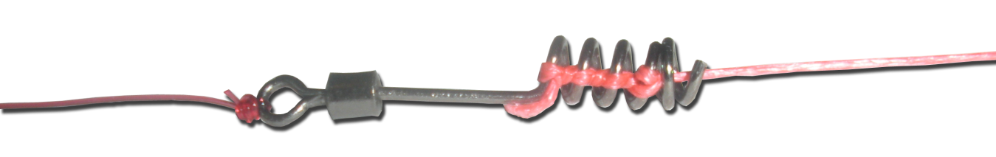

The Aussie Tackle ‘Knot Lock’ Braid to Monofilament Swivel connects braided

fishing line in seconds with one of the most exciting fishing advancements

seen in the fishing industry in many years. It is so easy to use that a 6 year

old can use it. It is simple, fast and very strong that every US angler will find it

a must-have for their tackle box.

Come see this amazing new product at the Tackle Kings booth #2037 at iCast.

Tackle Kings will be offering a ‘show-only’ special for any orders that are written

during the three exhibiting days of iCast. We will also conduct a raffle for an

iPod Touch for any company that places an order during the iCast show.

For more information about this product or any of the other Aussie Tackle ‘Knot

Lock’ products please call our office at Toll-Free 855-TACKLE-1. Ron Lewis

will be extension 1 and Doug Towle will be extension 2. You can also take a

look at our new website at <http://www.usfishingtackleonline.com>.