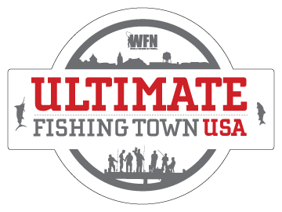

<Insert Date>

Dear <insert name of recipient>,

WFN: World Fishing Network is searching for the Ultimate Fishing Town USA and I think <insert name of town> is definitely the ultimate place to fish! The winning town will win a $25,000 community donation to be used towards any fishing-related causes, featured on WFN, 10 brand new reels donated by WaveSpin and a media / check presentation.

We have until April 8th to nominate our town by submitting photos, videos and testimonials at www.WFNFishingTown.com . I have already nominated <insert name of town> and need your help! Please add to our towns’ nomination before April 8th so we can best showcase <insert name of town> as the Ultimate Fishing Town.

Another fantastic thing about this promotion is that the public chooses the winner! Starting April 12th, our town will be subject to public voting. We have to be in the top 2 in our region in order to advance. Let’s work together and make sure that this happens. We can start a Facebook page, YouTube channel and even reach out to the local media to help gain support and voters! Let’s start working on ideas now so we are prepared when the voting begins.

Only 20 towns make it into the finals – let’s make sure we get there!

I think <insert name of town> is DEFINITELY the Ultimate Fishing Town! Let’s prove it to America and win this competition! Think of all the amazing things we can do with the donation <insert examples here>.

Check out www.WFNFishingTown.com to learn more about how it works and to see how last years winner benefited from being crowned WFN’s Ultimate Fishing Town.

Sincerely,

<insert your name>

