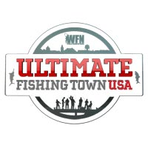

<Insert Date>

Dear <insert name of recipient>,

<insert name of town> is a finalist in WFN’s Ultimate Fishing Town!

WFN: World Fishing Network is searching for the Ultimate Fishing Town USA and <insert name of town> could win a $25,000 community donation to be used towards any fishing-related causes, featured on WFN, 10 brand new reels donated by WaveSpin and a media / check presentation.

The voting is in the final phase we need to rally our townspeople, friends, family, co-workers and anyone who loves to fish to vote for <insert name of town>. It is really easy to vote. Visit www.WFNFishingTown.com and enter the name of our town and vote. That’s it! You can vote up to 4 times a day during the designated voting blocks. I am making sure I maximize my votes!

Voting ends at 6:00pm ET on May 31st, so let’s get moving!

Anything you can do to help spread the word would help. You can blog about it, post on your Facebook, twitter or even bring it up at your next club meeting. The more people you can tell about our town, the more votes we will get!

I think <insert name of town> is DEFINITELY the Ultimate Fishing Town! Let’s prove it to America and win this competition! Think of all the amazing things we can do with the donation <insert examples here>.

Check out www.WFNFishingTown.com to learn more about how it works and to see how last years winner benefited from being crowned WFN’s Ultimate Fishing Town.

Sincerely,

<insert your name>

