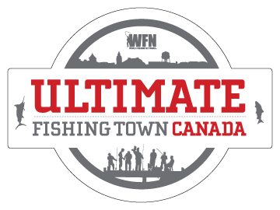

Dear <insert name of recipient>,

WFN: World Fishing Network is searching for Canada’s Ultimate Fishing Town and I think <insert name of town> is definitely the ultimate place to fish! The winning town will win a $25,000 community donation to be used towards any fishing-related causes, a 30-minute feature on WFN, 10 brand new reels donated by WaveSpin and a media / check presentation.

Starting March 1st, we can nominate our town by submitting photos, videos and testimonials at www.WFNFishingTown.com . I am already working on my nomination so we can be one of the first towns to enter. The great thing is that you can have an unlimited amount of supporting entries! Let’s get everyone together and start working on all the entries and make the town of <insert name of town> look incredible!

Another fantastic thing about this promotion is that the public chooses the winner! On April 8th every town who has nominated themselves is open to a public vote. We have to be in the top 3 in our region in order to advance. Let’s work together and make sure that this happens. We can start a Facebook page, YouTube channel and even reach out to the local media to help gain support and voters! Let’s start working on ideas now so we are prepared when the voting begins.

Only 20 towns make it into the finals – let’s make sure we get there!

I think <insert name of town> is DEFINITELY the Ultimate Fishing Town! Let’s prove it to Canada and win this competition! Think of all the amazing things we can do with the donation <insert examples here>.

Check out www.WFNFishingTown.com to learn more about how it works and to see how last years winner benefited from being crowned WFN’s Ultimate Fishing Town.

Sincerely,

<insert your name>

